Nama : Andre Setiawan
NRP : 5113100013

AB Benchmark

c=100
root@this-pc:/home/dhz# ab -n 5000 -c 100 http://localhost:8080/
This is ApacheBench, Version 2.3 <$Revision: 1528965 $>
Copyright 1996 Adam Twiss, Zeus Technology Ltd, http://www.zeustech.net/
Licensed to The Apache Software Foundation, http://www.apache.org/

Benchmarking localhost (be patient)
Completed 500 requests
Completed 1000 requests
Completed 1500 requests
Completed 2000 requests
Completed 2500 requests
Completed 3000 requests
Completed 3500 requests
Completed 4000 requests
Completed 4500 requests
Completed 5000 requests
Finished 5000 requests

Server Software:
Server Hostname: localhost
Server Port: 8080

Document Path: /
Document Length: 6 bytes

Concurrency Level: 100
Time taken for tests: 1.408 seconds
Complete requests: 5000
Failed requests: 0
Total transferred: 125000 bytes
HTML transferred: 30000 bytes
Requests per second: 3551.25 [#/sec] (mean)
Time per request: 28.159 [ms] (mean)
Time per request: 0.282 [ms] (mean, across all concurrent requests)
Transfer rate: 86.70 [Kbytes/sec] received

Connection Times (ms)
min mean[+/-sd] median max
Connect: 0 3 50.9 0 1000
Processing: 0 4 17.7 3 410
Waiting: 0 4 17.7 3 410
Total: 1 7 64.7 3 1407

Percentage of the requests served within a certain time (ms)
50% 3
66% 3
75% 3
80% 3
90% 4
95% 5
98% 6
99% 7
100% 1407 (longest request)

c=500
root@this-pc:/home/dhz# ab -n 5000 -c 500 http://localhost:8080/
This is ApacheBench, Version 2.3 <$Revision: 1528965 $>
Copyright 1996 Adam Twiss, Zeus Technology Ltd, http://www.zeustech.net/
Licensed to The Apache Software Foundation, http://www.apache.org/

Benchmarking localhost (be patient)
Completed 500 requests
Completed 1000 requests
Completed 1500 requests
Completed 2000 requests
Completed 2500 requests
Completed 3000 requests
Completed 3500 requests
Completed 4000 requests
Completed 4500 requests
apr_socket_recv: Connection reset by peer (104)
Total of 4832 requests completed

BENCHMARK DENGAN J-METER

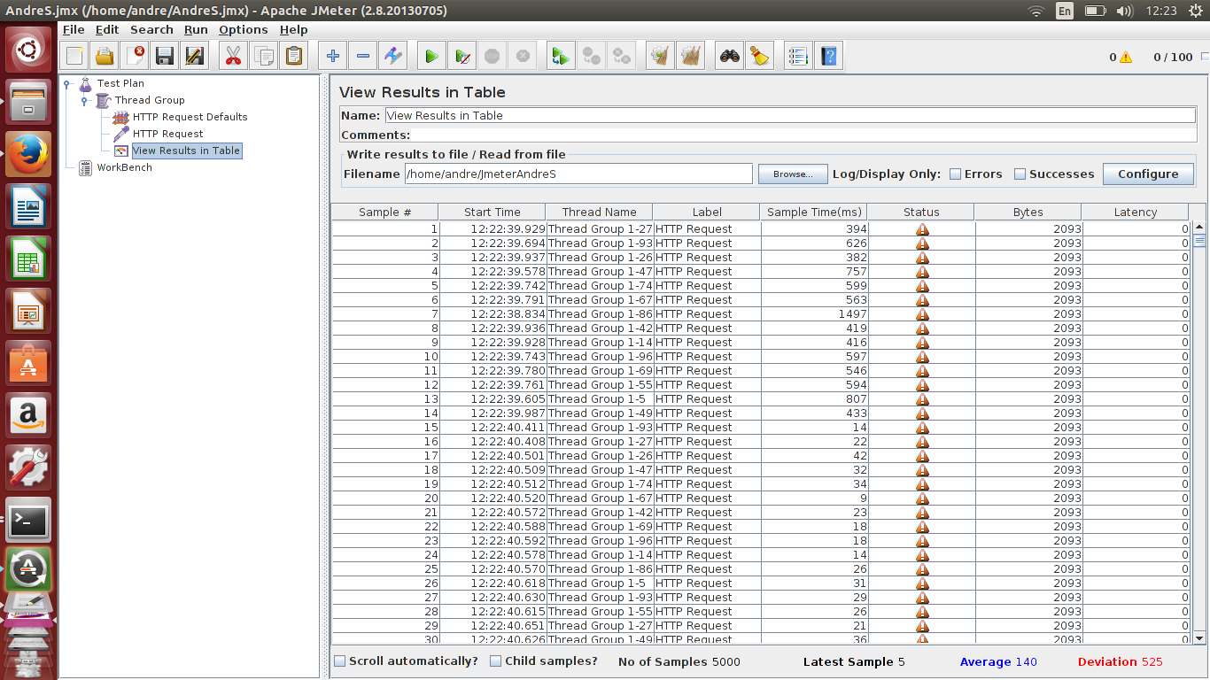
Banyak sampel = 5000

